- Directory Structure
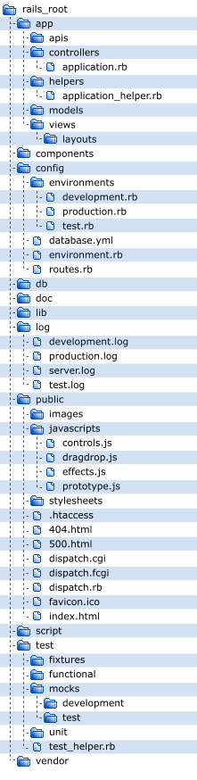
Figure 1 The figure above is a directory structure of the OASIS. This directory structure is already automatically generated by the Ruby on Rails framework.

